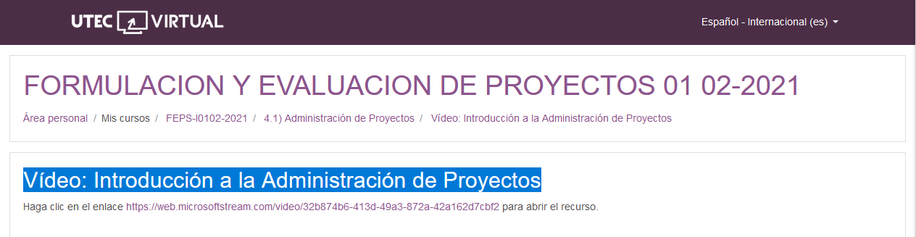

<https://web.microsoftstream.com/video/32b874b6-413d-49a3-872a-42a162d7cbf2>